**Maak dit na:**

Responsive maken:

1. col-md =

index.html

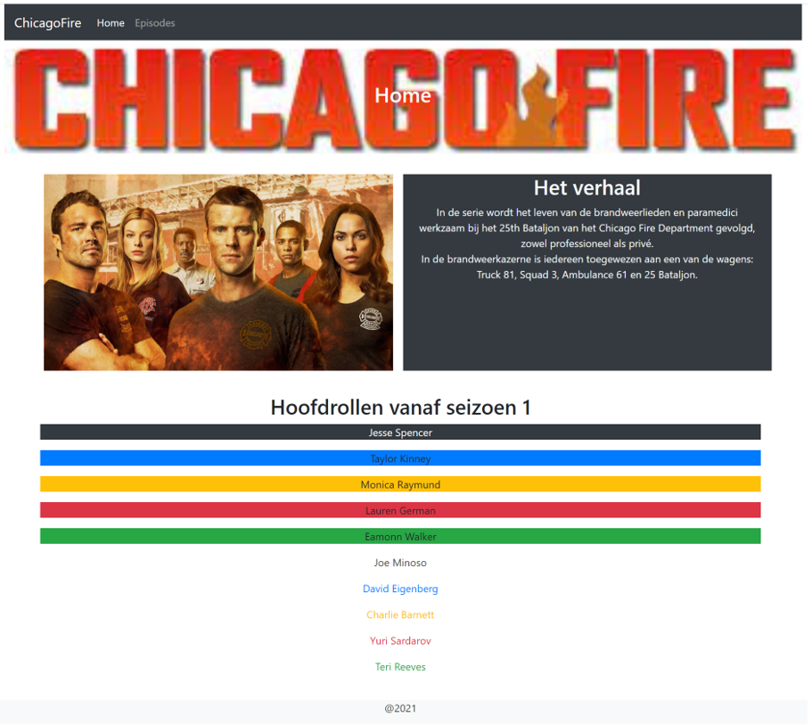

episode.html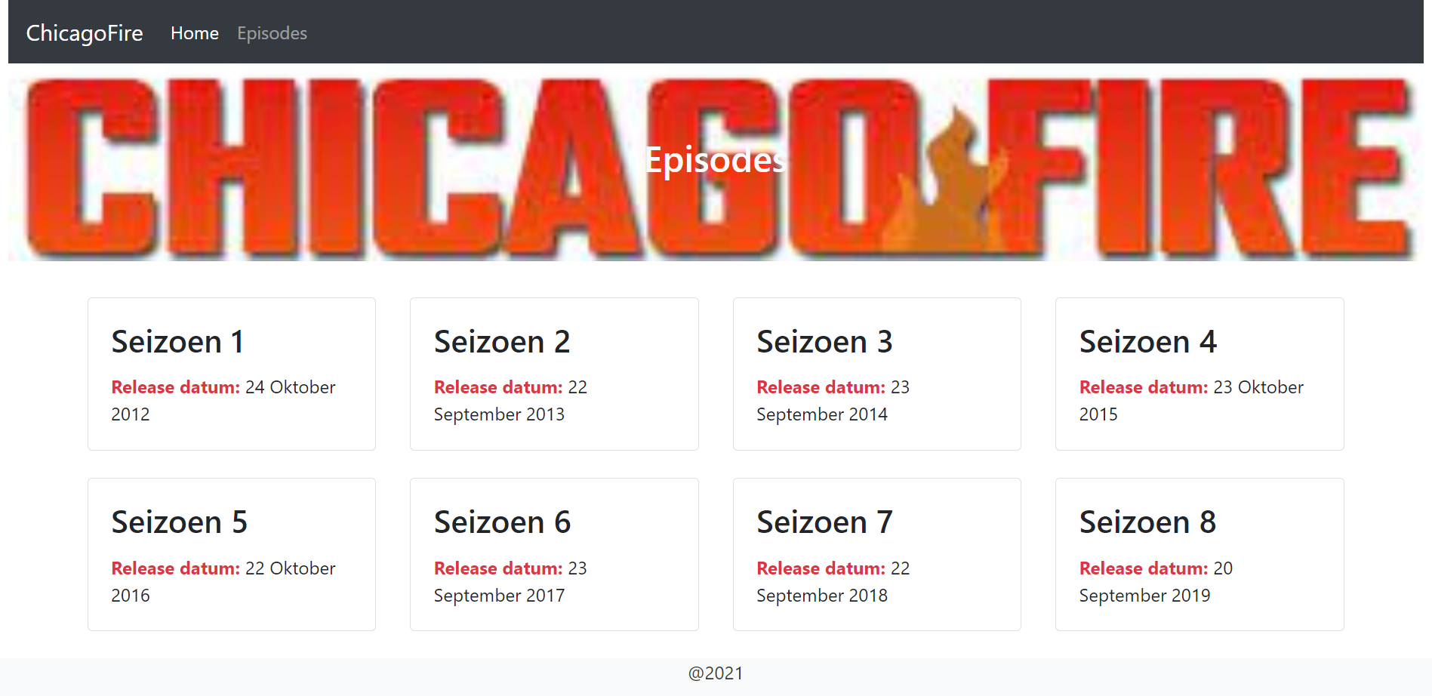

1. Mobiele versie (klein)

|  |  |
| --- | --- |
| index.html | epsiode.html |